# **Finance and Risk Analytics Group Assignment**

**Building Equity Portfolio**

Group 7

Venkatesh Taduvayi

Deeshant Kamal

Paarth Tiwari

Contents

**Finance and Risk Analytics Group Assignment** 1

0. Problem Statement 3

1. Data Preparation 4

2. Exploratory Data Analysis 4

a) Data summary 4

b) Univariate Analysis 4

3. Stock Portfolio with equal weightage 4

➢ Recommendations 4

4. Stock Portfolio with maximum return 4

➢ Recommendations 4

5. Stock Portfolio with minimum risk 4

➢ Recommendations 4

6. Portfolio with maximum Sharpe Ratio 4

➢ Recommendations 4

Appendix 6

## Problem Statement

**“You are an Equity fund manager focusing in large cap shares, your client has approached you and expressed in interest in building a portfolio of INR 1 Crore, in high-quality blue-chip shares.**

His criteria for investment are the investment universe is only blue-chip shares (share should be part of Sensex) and he would like to investment only in 5 shares among this universe. With maximum exposure of 30% in a single share.

He has requested you to provide various portfolios with various scenarios.

**Guidance for participants**

* Please download historical share prices from BSE India website. (minimum 2 years data of 10 shares along with share price, 2 excel sheet can be used)
* Use the tools taught in Market risk and portfolio optimization to provide various portfolios options to the client, like portfolio with minimum risk, maximum return, various combination in between.
* Please also provide a small write up on various portfolio along portfolio results based on historical share prices so that client can take a decision.”

Scoring guide (Rubric) - FRA-Rubric

|  |  |
| --- | --- |
| **Criteria** | **Points** |
| Download the 2 years historical data for 10 blue chips companies | 4 |
| Perform EDA on the data | 8 |
| Share inferences on EDA | 3 |
| Perform univariate analysis on the data | 6 |
| Share inferences on Univariate analysis | 4 |
| Create a portfolio of 5 stocks with equal weightage | 7 |
| Share recommendations from the portfolio | 3 |
| Create a portfolio of 5 stocks with maximum return | 7 |
| Share recommendations from the portfolio | 3 |
| Create a portfolio of 5 stocks with minimum risk | 7 |
| Share recommendations from the portfolio | 3 |
| Which Portfolio will give the maximum Sharpe ratio | 5 |

## Data Preparation

For this study, weekly data for the following stocks were obtained from BSE for the period March 2019 to March 2021:

|  |  |
| --- | --- |
| **Company** | **BSE Symbol** |
| Indian Tobacco Company Limited (ITC) | ITC.BO |
| Hindustan Unilever Limited (HUL) | HINDUNILVR.BO |
| Reliance Industries | RELIANCE.BO |
| Tata Consultancy Services (TCS) | TCS.BO |
| Oil and Natural Gas Corporation (ONGC) | ONGC.BO |
| Housing Development Finance Corporation (HDFC) | HDFC.BO |
| Infosys | INFY.BO |
| Eicher Motors | EICHERMOT.BO |
| Sun Pharmaceuticals Industries Limited | SUNPHARMA.BO |
| State Bank of India | SBIN.BO |

## Exploratory Data Analysis

### Data summary

* The dataset contains 105 observations for the above-mentioned 10 stocks.
* Following table describes the summary of the adjusted closing price of these stocks:

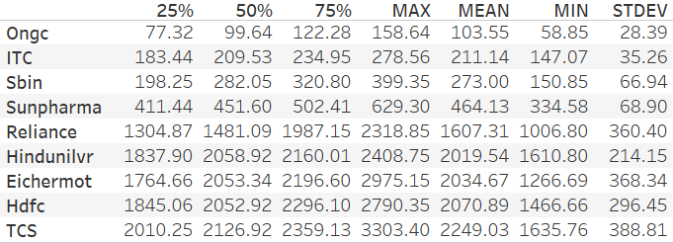

* Following table shows the fundamentals of these stocks:
* Correlation plot

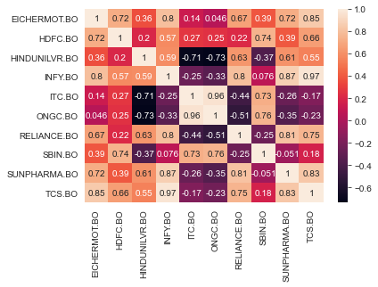

**Observations**:

* From the correlation plot we can see that the following pairs are highly corelated:
  + Infy TCS
  + ITC and HUL - -ve
  + ONGC and ITC

### Univariate Analysis of stock returns

#### Eicher Motors

|  |  |
| --- | --- |
| MEAN | 0.31% |
| STDEV | 5.44% |
| COV | 1767.52% |

|  |  |
| --- | --- |
| Worst 1% return scenario: |  |
|  | % loss on weekly basis |
| Historical Simulation | -11.53% |
| Parametric Method(normality) | -12.34% |
| Sample Scenario |  |
| Stocks purchased | 1000 |
| Total Investment | 2112166.75 |
| Avg weekly returns | 2227023.82 |
| Worst 1% loss: HIST |  |
|  | 1970218.30 |
| weekly caution deposit to cover for worst 1% loss | 256805.52 |
|  |  |
| Worst 1% loss: PARAM |  |
|  | 1952148.00 |
| weekly caution deposit  to cover for worst 1% loss | 274875.81 |

#### HDFC

|  |  |
| --- | --- |
| MEAN | 0.43% |
| STDEV | 5.32% |
| COV | 1239.72% |

|  |  |
| --- | --- |
| Worst 1% return scenario: |  |
|  | % loss on weekly basis |
| Historical Simulation | -14.44% |
| Parametric Method(normality) | -11.95% |
| **Sample Scenario** |  |
| Stocks | 1000 |
| Total Investment | 1911893.68 |
| Avg weekly returns | 2013618.94 |
| Worst 1% loss: HISTORIC |  |
|  | 1722842.18 |
| weekly caution deposit to cover for worst 1% loss | 290776.76 |
|  |  |
| Worst 1% loss: PARAMETRIC |  |
|  | 1773021.41 |
| weekly caution deposit  to cover for worst 1% loss | 240597.53 |

#### Hindustan Unilever

|  |  |
| --- | --- |
| MEAN | 0.33% |
| STDEV | 3.05% |
| COV | 935.30% |

|  |  |
| --- | --- |
| Worst 1% return scenario: |  |
|  | % loss on weekly basis |
| Historical Simulation | -6.01% |
| Parametric Method(normality) | -6.78% |
| **Sample Scenario** |  |
| Stocks | 1000 |
| Total Investment | 1648603.39 |
| Avg weekly returns | 1653984.73 |
| Worst 1% loss: HISTORIC |  |
|  | 1554544.85 |
| weekly caution deposit to cover for worst 1% loss | 99439.87 |
|  |  |
| Worst 1% loss: PARAMETRIC |  |
|  | 1541912.74 |
| weekly caution deposit  to cover for worst 1% loss | 112071.98 |

#### Infosys

|  |  |
| --- | --- |
| MEAN | 0.79% |
| STDEV | 4.49% |
| COV | 570.76% |

|  |  |
| --- | --- |
| Worst 1% return scenario: |  |
|  | % loss on weekly basis |
| Historical Simulation | -10.71% |
| Parametric Method(normality) | -10.67% |
| **Sample Scenario** |  |
| Stocks | 1000 |
| Total Investment | 676167.85 |
| Avg weekly returns | 681483.71 |
| Worst 1% loss: HISTORIC |  |
|  | 608508.20 |
| weekly caution deposit to cover for worst 1% loss | 72975.51 |
|  |  |
| Worst 1% loss: PARAMETRIC |  |
|  | 608775.78 |
| weekly caution deposit  to cover for worst 1% loss | 72707.92 |

#### ITC

|  |  |
| --- | --- |
| MEAN | -0.14% |
| STDEV | 4.52% |
| COV | -3128.77% |

|  |  |
| --- | --- |
| Worst 1% return scenario: |  |
|  | % loss on weekly basis |
| Historical Simulation | -10.71% |
| Parametric Method(normality) | -10.67% |
| **Sample Scenario** |  |
| Stocks | 1000 |
| Total Investment | 265210.144 |
| Avg weekly returns | 264826.6643 |
| Worst 1% loss: HISTORIC |  |
|  | 236468.1566 |
| weekly caution deposit to cover for worst 1% loss | 28358.51 |
|  |  |
| Worst 1% loss: PARAMETRIC |  |
|  | 236572.1418 |
| weekly caution deposit  to cover for worst 1% loss | 28254.52 |

#### ONGC

|  |  |
| --- | --- |
| MEAN | -0.01% |
| STDEV | 6.01% |
| COV | -61355.83% |

|  |  |
| --- | --- |
| Worst 1% return scenario: |  |
|  | % loss on weekly basis |
| Historical Simulation | -11.40% |
| Parametric Method(normality) | -13.99% |
| **Sample Scenario** |  |
| Stocks | 1000 |
| Total Investment | 140688.6749 |
| Avg weekly returns | 140674.8937 |
| Worst 1% loss: HISTORIC |  |
|  | 124641.0905 |
| weekly caution deposit to cover for worst 1% loss | 16033.80 |
|  |  |
| Worst 1% loss: PARAMETRIC |  |
|  | 120992.3881 |
| weekly caution deposit  to cover for worst 1% loss | 19682.51 |

#### Reliance

|  |  |
| --- | --- |
| MEAN | 0.58% |
| STDEV | 4.63% |
| COV | 801.16% |

|  |  |
| --- | --- |
| Worst 1% return scenario: |  |
|  | % loss on weekly basis |
| Historical Simulation | -11.11% |
| Parametric Method(normality) | -10.20% |
| **Sample Scenario** |  |
| Stocks | 1000 |
| Total Investment | 1310466.797 |
| Avg weekly returns | 1318046.061 |
| Worst 1% loss: HISTORIC |  |
|  | 1171623.165 |
| weekly caution deposit to cover for worst 1% loss | 146422.90 |
|  |  |
| Worst 1% loss: PARAMETRIC |  |
|  | 1183591.953 |
| weekly caution deposit  to cover for worst 1% loss | 134454.11 |

#### SBI

|  |  |
| --- | --- |
| MEAN | 0.45% |
| STDEV | 6.80% |
| COV | 1495.28% |

|  |  |
| --- | --- |
| Worst 1% return scenario: |  |
|  | % loss on weekly basis |
| Historical Simulation | -12.41% |
| Parametric Method(normality) | -15.36% |
| **Sample Scenario** |  |
| Stocks | 1000 |
| Total Investment | 297700.0122 |
| Avg weekly returns | 299053.4585 |
| Worst 1% loss: HISTORIC |  |
|  | 261945.5491 |
| weekly caution deposit to cover for worst 1% loss | 37107.91 |
|  |  |
| Worst 1% loss: PARAMETRIC |  |
|  | 253118.9126 |
| weekly caution deposit  to cover for worst 1% loss | 45934.55 |

#### Sun Pharmaceuticals

|  |  |
| --- | --- |
| MEAN | 0.39% |
| STDEV | 4.61% |
| COV | 1171.47% |

|  |  |
| --- | --- |
| Worst 1% return scenario: |  |
|  | % loss on weekly basis |
| Historical Simulation | -7.55% |
| Parametric Method(normality) | -10.33% |
| **Sample Scenario** |  |
| Stocks | 1000 |
| Total Investment | 453406.9214 |
| Avg weekly returns | 455190.9762 |
| Worst 1% loss: HISTORIC |  |
|  | 420829.5441 |
| weekly caution deposit to cover for worst 1% loss | 34361.43 |
|  |  |
| Worst 1% loss: PARAMETRIC |  |
|  | 408170.8883 |
| weekly caution deposit  to cover for worst 1% loss | 47020.09 |

#### TCS

|  |  |
| --- | --- |
| MEAN | 0.52% |
| STDEV | 3.89% |
| COV | 755.78% |

|  |  |
| --- | --- |
| Worst 1% return scenario: |  |
|  | % loss on weekly basis |
| Historical Simulation | -8.97% |
| Parametric Method(normality) | -8.54% |
| **Sample Scenario** |  |
| Stocks | 1000 |
| Total Investment | 1938674.561 |
| Avg weekly returns | 1948659.377 |
| Worst 1% loss: HISTORIC |  |
|  | 1773782.995 |
| weekly caution deposit to cover for worst 1% loss | 174876.38 |
|  |  |
| Worst 1% loss: PARAMETRIC |  |
|  | 1782236.953 |
| weekly caution deposit  to cover for worst 1% loss | 166422.42 |

### Worse 1% case scenario

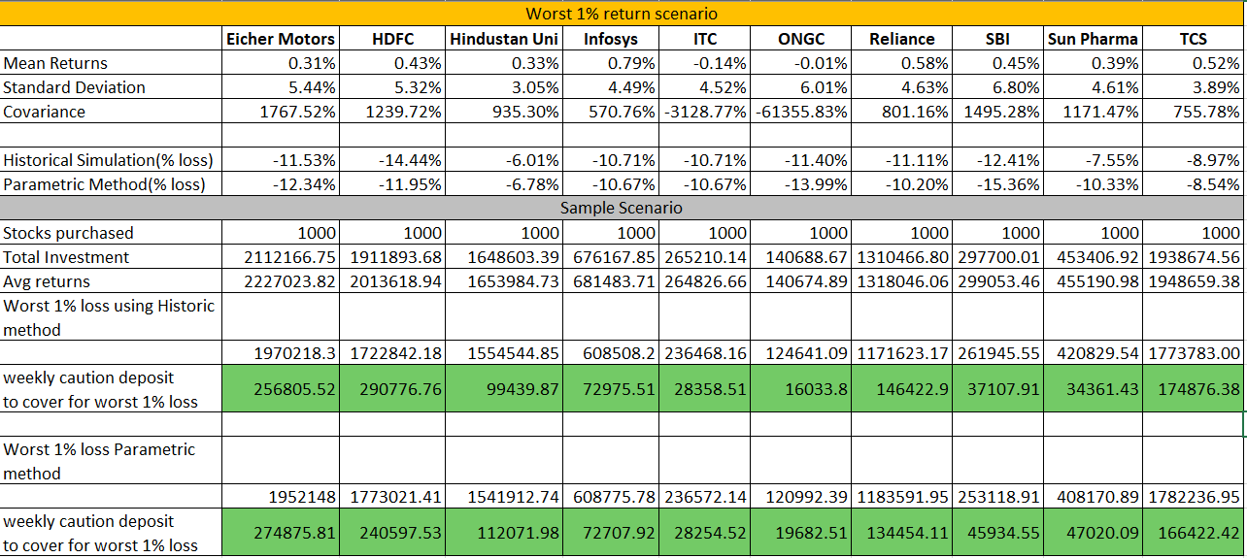

## Stock Portfolio with equal weightage

Steps go here

### Recommendations

Steps go here

## Stock Portfolio with maximum return

Steps go here

### Recommendations

Steps go here

## Stock Portfolio with minimum risk

Steps go here

### Recommendations

Steps go here

## Portfolio with maximum Sharpe Ratio

Steps go here

### Recommendations

Steps go here

# Appendix

* 1. Source data file:

